ASSIGNMENT

**Trigger 3**

Create a table with 2 number fields a and b. Write a trigger so that the value that is entered into the table satisfies the condition: a+b>75. Also if value of b is changed, it should not be changed to a smaller value. Tuples that violate these conditions should not be entered.

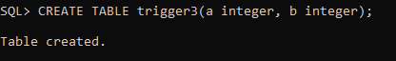

**Trigger:**

CREATE OR REPLACE TRIGGER t3

BEFORE INSERT OR UPDATE ON trigger3

FOR EACH ROW

BEGIN

IF (INSERTING) THEN

IF (:NEW.a+:NEW.b < 75) THEN

RAISE_APPLICATION_ERROR(-20001, 'A+B is less than 75');

END IF;

ELSE

IF (:NEW.b < :OLD.b) THEN

RAISE_APPLICATION_ERROR(-20001, 'New B is less than old B');

END IF;

END IF;

END;

